Chapter 15: Air Pollution

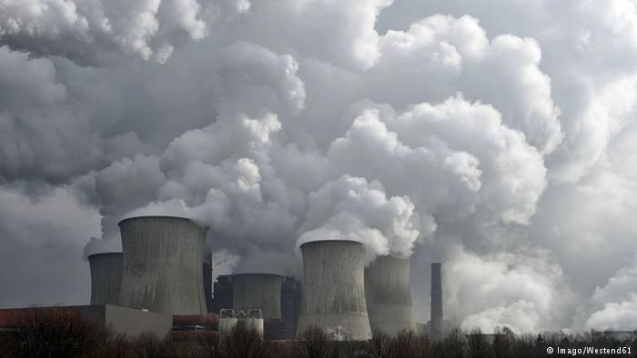

Can you….

1. Identify and describe the major air pollutants
2. Describe the sources of air pollution
3. Explain how photochemical smog forms and why it is still a problem in the United States
4. Describe how acid deposition forms and why it has improved in the United States and become worse elsewhere
5. Explain strategies and techniques for controlling sulfur dioxide, nitrogen oxides, and particulate matter
6. Describe innovative pollution control measures
7. Explain the benefits of stratospheric ozone and how it forms
8. Describe the depletion of stratospheric ozone
9. Explain efforts to reduce ozone depletion
10. Explain how indoor air pollution differs in developing and developed countries
11. Describe the major indoor air pollutants and the risks associated with them